**Resources for Families**

**______________________________________________**

**Lakes Market**

Diamond Lakes Elementary School has partnered with Golden Harvest Food Bank to provide shelf-stable foods free for DLE families in need.

Lakes Market is open once per week (when school is in session), but we will be happy to accommodate you if you are not able to visit during the specified time. We have a “shopping” option and backpack option available.

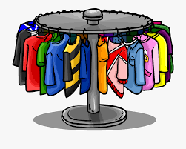For more information, please contact the school counselor, Mrs. Abellan (see back of pamphlet).

**Gems Closet:**

Diamond Lakes Elementary is excited to present our Gems Closet, full of generously donated clothes in a wide range of sizes (toddlers to adults). The closet will be open upon request. Please contact Mrs. Abellan if you are interested.





**Contact**

Please contact the school counselor for more information about Diamond Lakes Elementary School Counseling Program and services:

**School Counselor:**

Kathryn Abellan

(706) 771-2881 ext. 2224

[abellka@boe.richmond.k12.ga.us](mailto:abellka@boe.richmond.k12.ga.us)



**Diamond Lakes Elementary School Counseling Program and Services**

___________________________________



**Diamond Lakes Elementary School**

4153 Windsor Spring Rd. Hephzibah, GA 30815

706-771-2881

<https://www.rcboe.org/diamondlakes>

**What Does a School Counselor Do?**

________________________________________________

* Classroom Guidance
* Group counseling
* Individual counseling
* Parent & faculty consultation
* Assist with academic intervention plans & implementation
* Conflict resolution
* Coordinate school-wide programs
* Crisis intervention
* Referrals

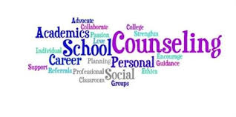

**Classroom Guidance**

________________________________________________

Classroom guidance lessons are developed from state & county adopted curriculums. Lessons cover information including:

* Academic organizational, study, & test-taking skills
* Goal setting & decision making
* Career exploration & planning
* Character Education
* Self-awareness
* Peer relationships
* Emotional Identification & Regulation
* Social skills
* Effective communication
* Problem-solving & conflict resolution
* Multicultural/diversity awareness

**Referrals**

____________________________________________

A student may be referred to the counselor by:

* Teachers
* Parents
* Administrators
* Student (self-referral)

The counselor may refer students and parents to community resources if needed.

**Permission**

_________________________________________

Counselors obtain parental permission to see students for individual and group sessions. Counselors may meet with a student once without parental permission. If there is a need to see the student again, parental permission is required.

